RINGKASAN HASIL AKHIR
DATASET INFORMATION:
Total Samples: 1500
Features After Selection: 10
Target Classes: ['Lancar', 'Tidak Lancar']

FEATURE SELECTION RESULTS:
FEATURE SELECTION (Chi-Square, MI, RF Importance)
1. CHI-SQUARE TEST
--------------------------------------------------------------------------------
Feature Chi2_Score P_Value
Status Aplikasi 261.356315 8.687099e-59
Hasil Prescreening Dukcapil 58.298701 2.251927e-14
Hasil Prescreening DHNBI 31.475248 2.019989e-08
Produk 2.212969 1.368551e-01
Hasil Prescreening SIPKUR 1.342741 2.465512e-01
Sub Produk 1.253607 2.628647e-01
Pekerjaan 0.463563 4.959636e-01
Jangka Waktu 0.036460 8.485681e-01
Plafond 0.005163 9.427208e-01
Status Pernikahan 0.000288 9.864514e-01
Usia 0.000234 9.878059e-01

2. MUTUAL INFORMATION
--------------------------------------------------------------------------------
Feature MI_Score
Status Aplikasi 0.241136
Produk 0.025440
Hasil Prescreening Dukcapil 0.022721
Sub Produk 0.014078
Hasil Prescreening DHNBI 0.014032
Plafond 0.011758
Pekerjaan 0.001533
Status Pernikahan 0.000000
Usia 0.000000
Jangka Waktu 0.000000
Hasil Prescreening SIPKUR 0.000000

3. RANDOM FOREST FEATURE IMPORTANCE
--------------------------------------------------------------------------------
Feature Importance
Status Aplikasi 0.479316
Hasil Prescreening Dukcapil 0.148729
Plafond 0.110028
Usia 0.091506
Jangka Waktu 0.074250
Pekerjaan 0.045549
Hasil Prescreening SIPKUR 0.014392
Status Pernikahan 0.011514
Hasil Prescreening DHNBI 0.010706
Sub Produk 0.008858
Produk 0.005152

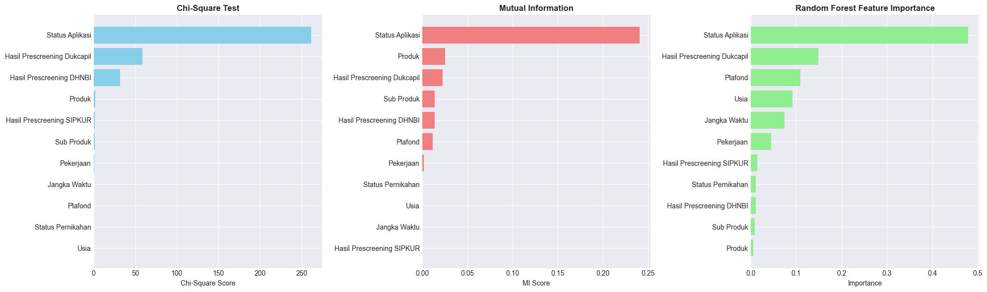

MASUK KE PROSES KOMBINASI DAN ELIMINASI FEATURE
RECURSIVE FEATURE ELIMINATION DAN AVARAGE
Final Selected Features (sorted by combined score):
1. Pekerjaan (Score: 0.8264) RFE Score
2. Usia (Score: 0.1591) RFE Score
3. Status Pernikahan (Score: 0.1082) Score
4. Produk (Score: 0.0528) Score
5. Sub Produk (Score: 0.0459) Score
6. Plafond (Score: 0.0330) RFE Score
7. Jangka Waktu (Score: 0.0075) RFE Score
8. Hasil Prescreening SIPKUR (Score: 0.0039) RFE
9. Hasil Prescreening Dukcapil (Score: 0.0036) RFE
10. Status Aplikasi (Score: 0.0017) RFE

DATA SPLITTING SCENARIOS:
--------------------------------------------------------------------------------
1. 80-20 Split: Train=1200 | Test=300
2. 70-30 Split: Train=1050 | Test=450
3. 60-40 Split: Train=900 | Test=600
4. 10-Fold CV: Total=1500 samples

COMPLETE COMPARISON: ALL MODELS × ALL SCENARIOS (Sorted by ROC-AUC)
Scenario Model Accuracy Precision Recall F1-Score ROC-AUC
60-40 Split Random Forest 0.921667 0.781095 0.981250 0.869806 0.954972
60-40 Split Gradient Boosting 0.915000 0.794595 0.918750 0.852174 0.954524
60-40 Split LightGBM 0.915000 0.788360 0.931250 0.853868 0.953445
60-40 Split XGBoost 0.916667 0.789474 0.937500 0.857143 0.953445
70-30 Split Gradient Boosting 0.913333 0.783217 0.933333 0.851711 0.953194
10-Fold CV LightGBM 0.914667 0.788786 0.935000 0.854791 0.951773
10-Fold CV XGBoost 0.914667 0.787142 0.940000 0.855470 0.951523
70-30 Split LightGBM 0.917778 0.782313 0.958333 0.861423 0.951389
70-30 Split XGBoost 0.913333 0.775510 0.950000 0.853933 0.950530
10-Fold CV Random Forest 0.915333 0.783077 0.950000 0.857746 0.950000
70-30 Split Random Forest 0.920000 0.780000 0.975000 0.866667 0.949192
10-Fold CV Gradient Boosting 0.912667 0.787797 0.925000 0.849959 0.948068
80-20 Split LightGBM 0.920000 0.797872 0.937500 0.862069 0.947386
80-20 Split Gradient Boosting 0.916667 0.795699 0.925000 0.855491 0.946875
80-20 Split Random Forest 0.920000 0.797872 0.937500 0.862069 0.945568
80-20 Split XGBoost 0.910000 0.784946 0.912500 0.843931 0.944830

BEST MODEL BEFORE TUNING:
Model: Random Forest
Scenario: 60-40 Split
Accuracy: 0.9217
Precision: 0.7811
Recall: 0.9812
F1-Score: 0.8698
ROC-AUC: 0.9550
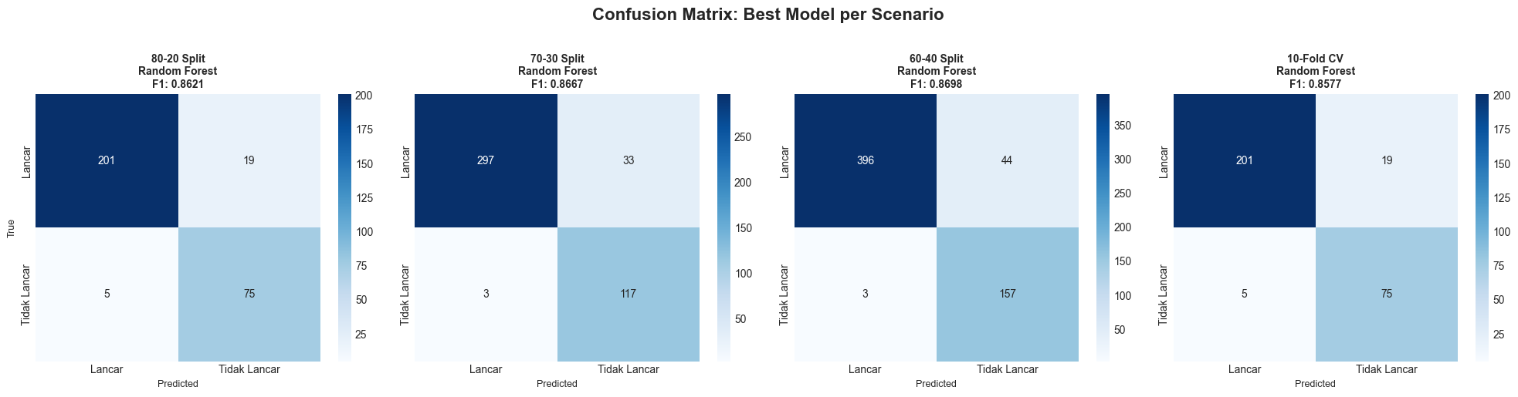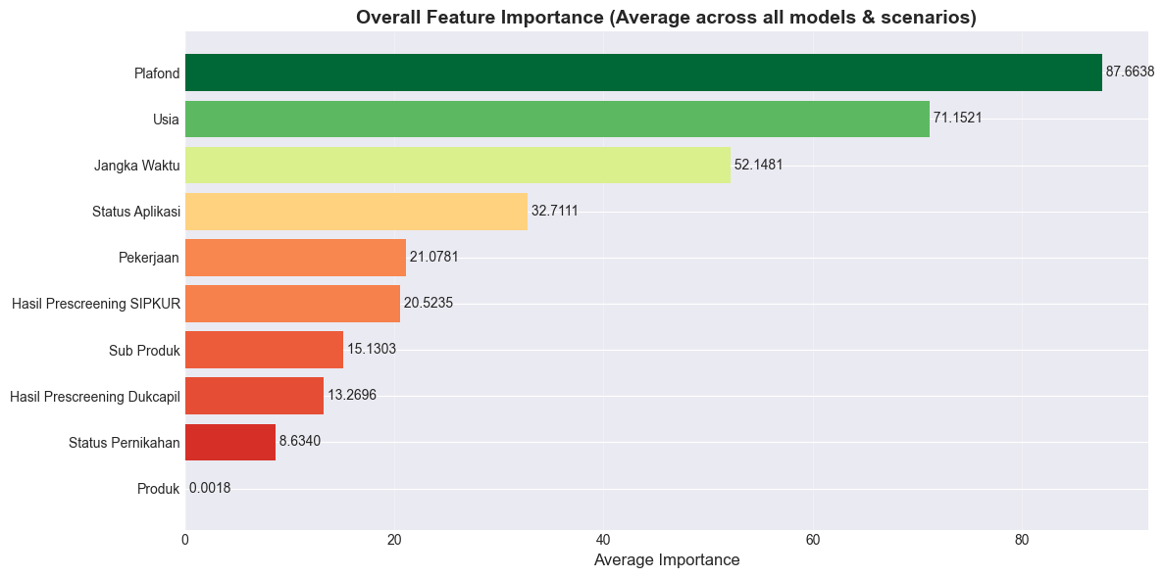
HYPERPARAMETER TUNING RESULTS:
SKENARIO SAMPLE :
Top 10 Parameter Combinations:
Rank 1:
Mean ROC-AUC: 0.9510 (± 0.0157)
Parameters: {'n_estimators': 100, 'min_samples_split': 5, 'min_samples_leaf': 1, 'max_features': 'log2', 'max_depth': 10, 'bootstrap': True}
Rank 2:
Mean ROC-AUC: 0.9509 (± 0.0164)
Parameters: {'n_estimators': 200, 'min_samples_split': 2, 'min_samples_leaf': 2, 'max_features': 'sqrt', 'max_depth': 10, 'bootstrap': True}
Rank 3:
Mean ROC-AUC: 0.9508 (± 0.0171)
Parameters: {'n_estimators': 100, 'min_samples_split': 2, 'min_samples_leaf': 2, 'max_features': 'log2', 'max_depth': 20, 'bootstrap': False}
Rank 4:
Mean ROC-AUC: 0.9506 (± 0.0169)
Parameters: {'n_estimators': 100, 'min_samples_split': 10, 'min_samples_leaf': 4, 'max_features': 'log2', 'max_depth': 10, 'bootstrap': False}
Rank 5:
Mean ROC-AUC: 0.9506 (± 0.0158)
Parameters: {'n_estimators': 200, 'min_samples_split': 5, 'min_samples_leaf': 2, 'max_features': 'log2', 'max_depth': 20, 'bootstrap': False}
Rank 6:
Mean ROC-AUC: 0.9505 (± 0.0169)
Parameters: {'n_estimators': 300, 'min_samples_split': 2, 'min_samples_leaf': 2, 'max_features': 'log2', 'max_depth': None, 'bootstrap': False}
Rank 6:
Mean ROC-AUC: 0.9505 (± 0.0173)
Parameters: {'n_estimators': 300, 'min_samples_split': 2, 'min_samples_leaf': 4, 'max_features': 'log2', 'max_depth': 25, 'bootstrap': False}
Rank 6:
Mean ROC-AUC: 0.9505 (± 0.0173)
Parameters: {'n_estimators': 300, 'min_samples_split': 2, 'min_samples_leaf': 4, 'max_features': 'log2', 'max_depth': None, 'bootstrap': False}
Rank 9:
Mean ROC-AUC: 0.9505 (± 0.0171)
Parameters: {'n_estimators': 200, 'min_samples_split': 10, 'min_samples_leaf': 4, 'max_features': 'sqrt', 'max_depth': 15, 'bootstrap': False}
Rank 10:
Mean ROC-AUC: 0.9504 (± 0.0161)
Parameters: {'n_estimators': 200, 'min_samples_split': 5, 'min_samples_leaf': 2, 'max_features': 'log2', 'max_depth': None, 'bootstrap': False}

Model Used: Random Forest
Dataset Used: 60-40 Split
ROC-AUC Before: 0.9550
ROC-AUC After: 0.9534
Improvement: -0.0015
Status: ⚠️ NO IMPROVEMENT (using original model)

CONFUSION MATRIX (After Tuning):
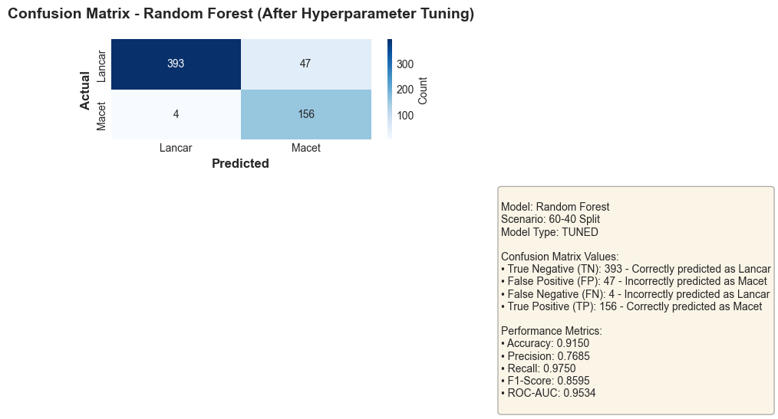

SAVED MODEL:
Directory: models/model_20260111_151051
Model Type: ORIGINAL
Final ROC-AUC: 0.9550
Final F1-Score: 0.8698

